Lab4

>> load children

% x is the age of 18 boys in months
% y is the height of 18 boys in cm.

>> x

x =

109
113
115
116
119
120
121
124
126
129
130
133
134
135
137
139
141
142

>> y

y =

137.6000
147.8000
136.8000
140.7000
132.7000
145.4000
135.0000
133.0000
148.5000
148.3000
147.5000
148.8000
133.2000
148.7000
152.0000
150.6000
165.3000
149.9000

>> [bet,yfitted,residual,xM]=resistantlines(x,y)

iteration =

1

bet =

146.0133
0.4933

yfitted =

136.8867
138.8600
139.8467
140.3400
141.8200
142.3133
142.8067
144.2867
145.2733
146.7533
147.2467
148.7267
149.2200
149.7133
150.7000
151.6867
152.6733
153.1667

residual =

0.7133
8.9400
-3.0467
0.3600
-9.1200
3.0867
-7.8067
-11.2867
3.2267
1.5467
0.2533
0.0733
-16.0200
-1.0133
1.3000
-1.0867
12.6267
-3.2667

xL =

115.5000

xM =

127.5000

xR =

138

iteration =

2

adjust =

-0.1519
-0.0705

delta =

Inf -0.0705

b =

0.4933 0.4933

condition =

Inf 0.1429

bet =

145.8614
0.4228

iteration =

3

adjust =

0.0031
0.0063

delta =

Inf -0.0705 0.0063

b =

0.4933 0.4933 0.4228

condition =

Inf 0.1429 0.0148

bet =

145.8645
0.4291

iteration =

4

adjust =

1.0e-003 *

-0.2786
-0.5572

delta =

Inf -0.0705 0.0063 -0.0006

b =

0.4933 0.4933 0.4228 0.4291

condition =

Inf 0.1429 0.0148 0.0013

bet =

145.8643
0.4285

bet =

145.8643
0.4285

yfitted =

137.9365
139.6506
140.5077
140.9362
142.2218
142.6503
143.0788
144.3644
145.2215
146.5071
146.9356
148.2212
148.6497
149.0782
149.9353
150.7923
151.6494
152.0779

residual =

-0.3365
8.1494
-3.7077
-0.2362
-9.5218
2.7497
-8.0788
-11.3644
3.2785
1.7929
0.5644
0.5788
-15.4497
-0.3782
2.0647
-0.1923
13.6506
-2.1779

xM =

127.5000
**************************************************

The first model constructed is

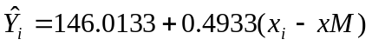

Depending on this first model residual values are calculated. Then, a resistant regression model is constructed by residual versus x values and the estimated intercept and slope are

gamma=-0.1519, delta=-0.0705

>> abs(-0.0705/0.4933)

ans =

0.1429

The absolute value of the proportion of delta to slope is |-0.0705/0.4933|=0.1429 which is not less than or equal to 0.01, so the iteration continues. The new intercept and slope values are calculated as

>> 146.0133+(-0.1519)

ans =

145.8614

>> 0.4933+(-0.0705)

ans =

0.4228

>> abs(0.0063/0.4228)

ans =

0.0149

Then, by using the new intercept and slope, residuals are calculated and new gamma and delta values are found as gamma=0.0031 and delta=0.0063. Since |0.0063/0.4228|=0.0149 is also not less than or equal to 0.01, iteration continues and new intercept and slope is again calculated

>> 145.8614+0.0031

ans =

145.8645

>> 0.4228+0.0063

ans =

0.4291

>> abs(-0.0005572/0.4291)

ans =

0.0013

Again after the same routine, new gamma and delta values are gamma=-0.0002786 and delta=-0.0005572. The condition is now |-0.0005572/0.4291|=0.0013 which is not greater than 0.01 and so the iteration stops. Now we can obtain the final model. Because of rounding errors, the values we calculate here manually may differ a little from the output of the program but they should be close. We use the values of the program to make estimation.

>> 145.8645-0.0002786

ans =

145.8642

>> 0.4291-0.0005572

ans =

0.4285

>> bet

bet =

145.8643
0.4285

The final model:

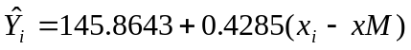

Now let us estimate the mean height of a boy who is 145 months old by using the final model.

>> bet(1)+bet(2)*(145-xM)

ans =

153.3635

It is also possible to compare the least squares regression line and resistant line. To obtain the least squares line, after writing the command given below we select Coefficients, Fitted Values and Leverage on the pop up window

>> regstats(y,x)

We can first observe the leverage effect of the observations on the fitted values. Please remind that an observation to have high leverage values doesn’t mean it is an outlier but one has to be careful about it.

>> n=18;

>> plot(x,leverage,'*')

>> 2*(1/n)

ans =

0.1111

If the leverage of the observation is greater than two times of 1/n, we should be careful about it.

>> leverage

leverage =

0.2352
0.1636
0.1346
0.1218
0.0902
0.0819
0.0748
0.0601
0.0559
0.0582
0.0612
0.0770
0.0846
0.0932
0.1139
0.1392
0.1689
0.1855
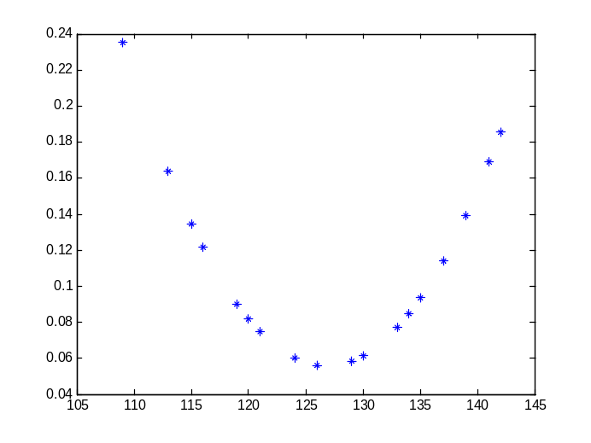

There are some values greater than 0.1111. If they are apparently outliers which can be detected from the scatter plot, they will have a huge effect on the fitted values.

Then we construct the scatter plot, the least squares line and the resistant line on the same plot. Here green line represents the resistant line and the red line represents the least squares line. We can see that the least squares line is a affected by the outlying observations, especially by the one with the circle around it. Here, the resistant line is representing the data set better.

>> plot(x,y,'*',x,yfitted,'g',x,yhat,'r')
